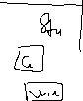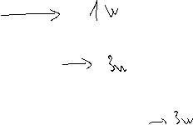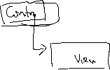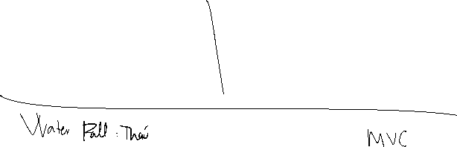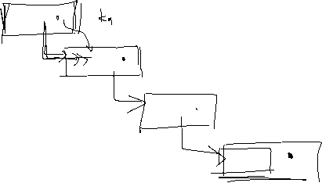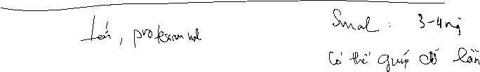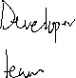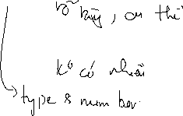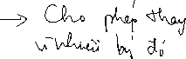

1. I suggest software development methodology is Agile for this situation, because:

* Requiment: It is clear and have function requiment for system and cutomer:

+ Automatic interaction via SMS, Email, WhatsApp, Zalo.

+ Send a personalized digital invoice with their branding.

+ Send live service updates.

+Send automatic vehicle service reminders.

+Send automatic service feedback and auto post them on all Google listings.

+ Get bookings from customer Android & iOS app.

* User involvement in the situation: high because GarageOne focuses on automated communication with their customers in which a simple application is used to interact and inform their customers.
* Team size: Small with 3 developers and 1 tester.
* Conclusion: In light of the foregoing evaluation, I feel that the Agile model is the most appropriate approach in this situation due to the frequent supply of requirements. Since the requirements system is flexible and subject to change at any time, it is appropriate to deploy the system first rather than developing it in stages.

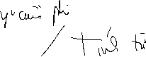

* List out 4 functional requirements system handler:

- Automatic interaction via SMS, Email, WhatsApp, Zalo.

- Send a personalized digital invoice with their branding.

- Send automatic vehicle service reminders.

- Get bookings from customer Android & iOS app.

* and 2 non- functional requirements of system:
* All of information is processed and stored in Ms Excel.
* To confirm the booking, customer should pay 10% of the total of temporary invoice.



* As a customer, I want to choose many services to book combining with date, type of car and required workers



* As a customer, I want to interacts with consultants to get further information through SMS, WhatsApp, Zalo, Email.

